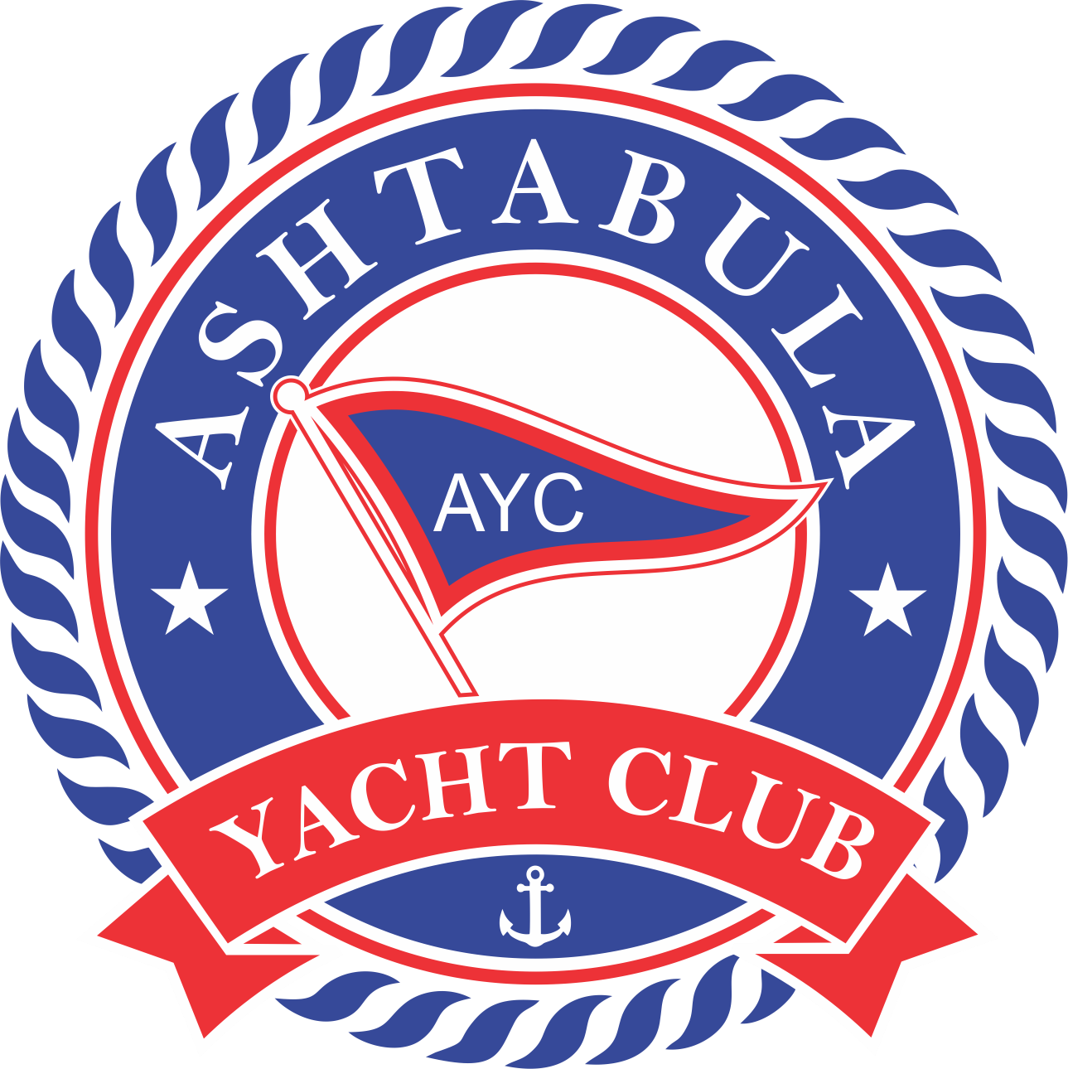 **2025** **Member Information Form**

**( This form as well as current proof of insurance must be presented to AYC Staff at time of launch**

|  |  |  |  |
| --- | --- | --- | --- |
| **Owners**  **Name and First Mate** |  | **Date:** |  |

**Address** **Contact Information**

|  |  |  |  |
| --- | --- | --- | --- |
| Street |  | Home # |  |
| City |  | Cell # |  |
| Zip |  | Work # |  |
| Email |  |  |  |

**Boat Information**

|  |  |  |  |
| --- | --- | --- | --- |
| Manufacturer: |  | Year: |  |
| Model: |  | Type: | Power Sail |
| L.O.A,: |  | Draft: |  |
| Beam: |  | Weight: |  |
| Registration # |  |  |  |

**Power**

|  |  |
| --- | --- |
| **Battery (DC)** | **Shore Power (AC)** |
| ___ Standard Wet Cell  ___ AGM  ___ Lithium  ___Other __________________________ | ___ Single 30A  ___ Double 30A  ___ Single 50A  ___ Double 50A |

**Ground Tackle**

|  |
| --- |
| **Type:** |
| ___ Trailer  ___ Cradle  ___ Jack Stands  ___Other_____________________ |

**Emergency Contacts, Survivor Information**

This information is in case of an emergency and the boat owner(s) can’t be reached, a vessel is missing, or there is an untimely death or disability of member. This generally would not be the “first mate”.

|  |  |
| --- | --- |
| **Emergency Contact / Beneficiary Name and Relationship** |  |

|  |  |  |  |
| --- | --- | --- | --- |
| Street |  | Home # |  |
| City, State |  | Cell # |  |
| Zip |  | Work # |  |
| Email |  |  |  |

|  |  |
| --- | --- |
| **Emergency Contact / Beneficiary Name and Relationship** |  |

|  |  |  |  |
| --- | --- | --- | --- |
| Street |  | Home # |  |
| City, State |  | Cell # |  |
| Zip |  | Work # |  |
| Email |  |  |  |